Faculty Section Graphs

Dhruv Rawat and Anurag Aribandi

Tasks : Graphs on Pg 2 and 3

Status: Working, no modifications required

Output:

Pg:2

Required

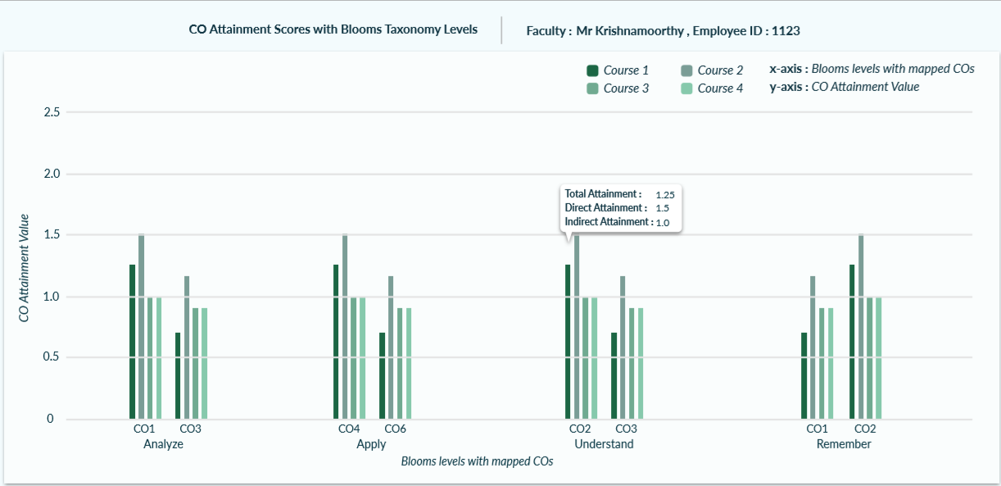

Final

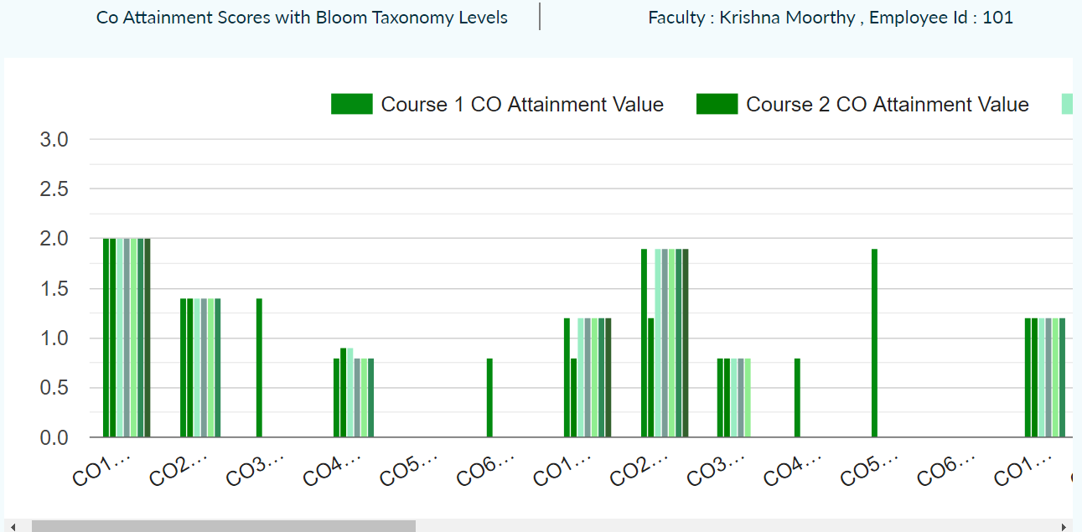

Pg 3

Required

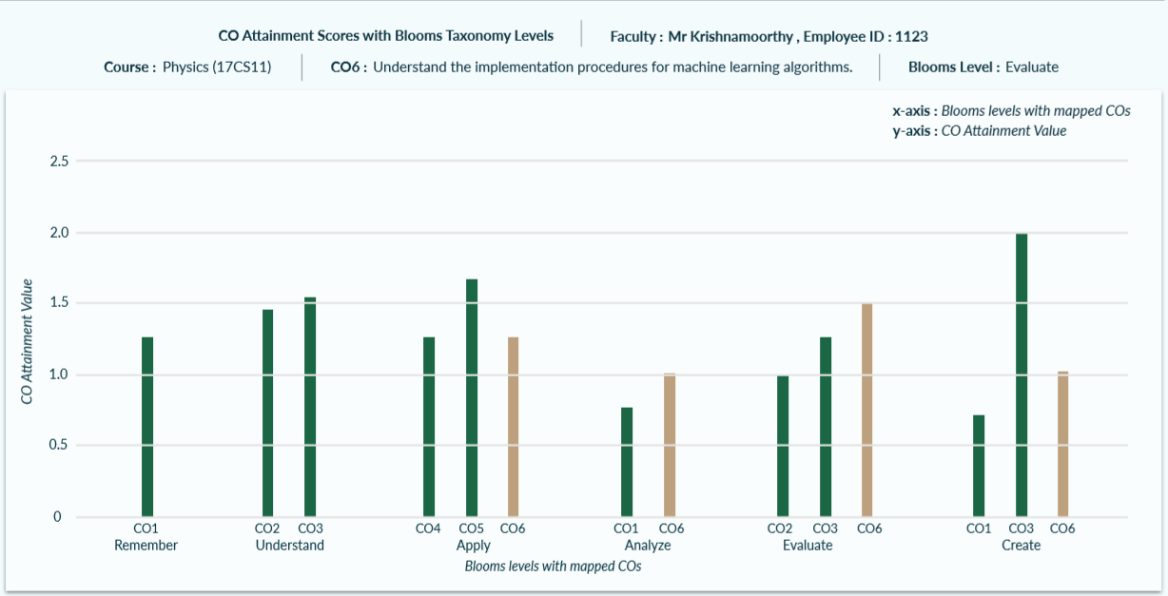

Final

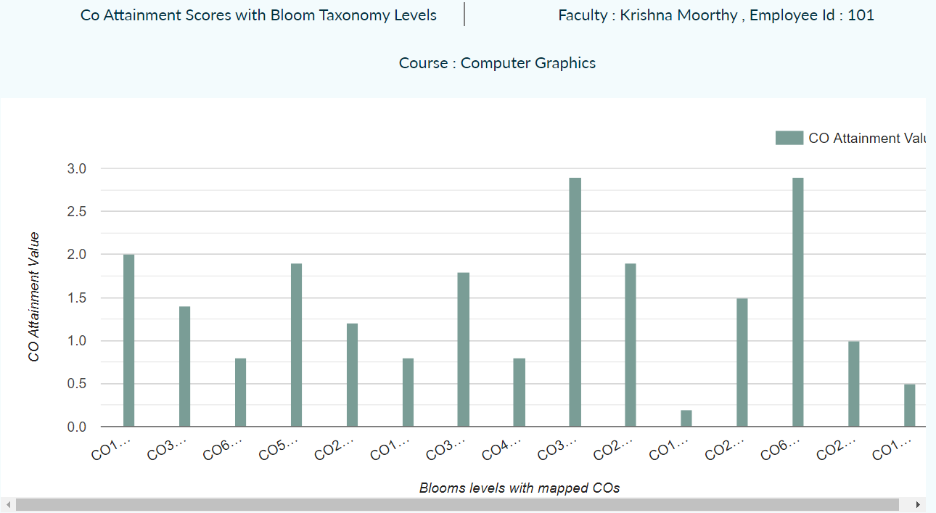

Student Section Graphs

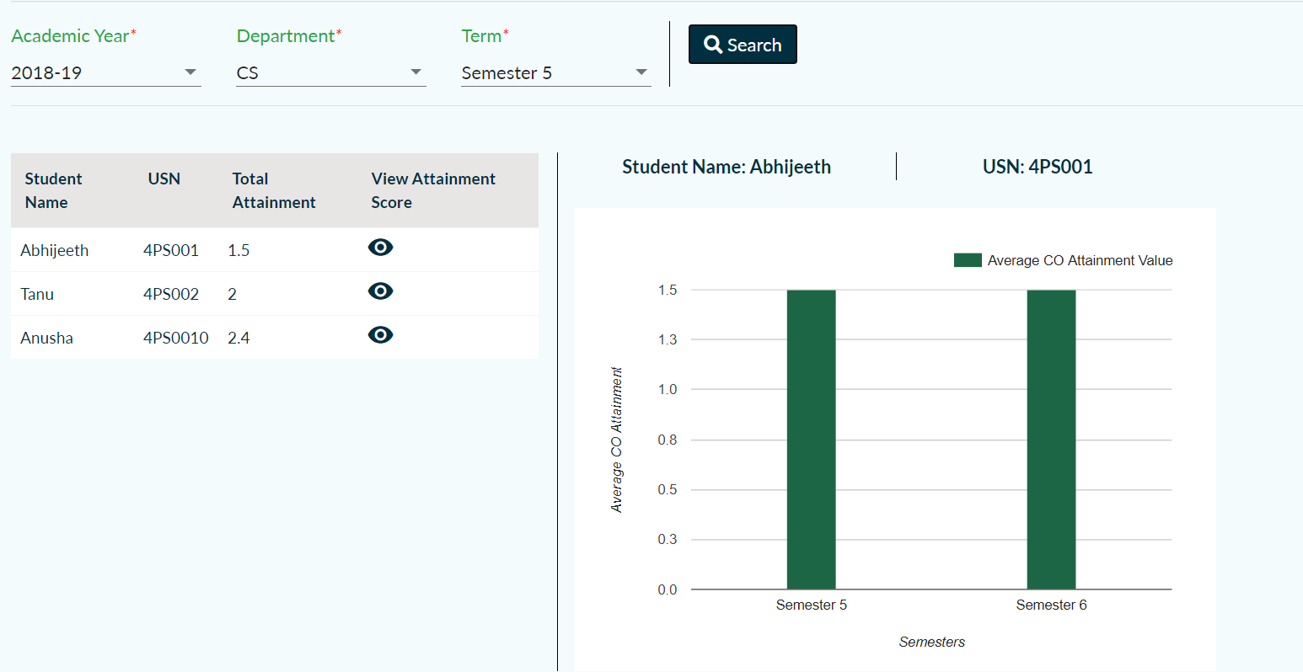

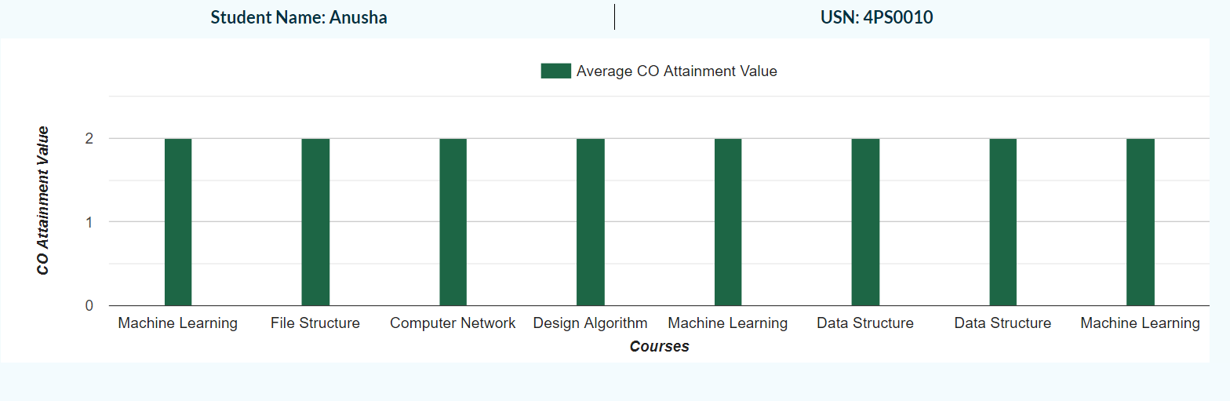

The first two graphs were completed, the interaction of the first graph is done. When toggling student section the information needs to be refreshed to empty instead of showing searched information from faculty part. The full student data that needs to be shown when the first graph is interacted with is not present but the course wise data is done. The co wise pie chary representation for each courses COs is yet to be completed

Search Bar Drop-down

Anish Mitta

Tasks : Implementing of search bar along with breadcrumbs

Status: Working, disable option needs to be added

Faculty-Student Toggle

Anish Mitta

Tasks : Toggle between faculty and students

Status: Working, very little styling required

Student Table

Anish Mitta

Tasks : Student table in the student section

Status: Working, no further styling required

Left Selection Pane

Sugam Agrawal and Anish Mitta

Tasks : Left Pane on pg2

Status: Working, Minor Styling changes required

Output:

Required:

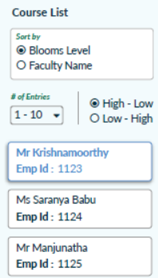

Final:

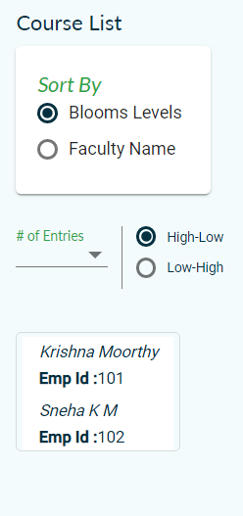

Table

Sugam Agrawal

Tasks : Table on page 3

Status: Working, Minor Styling changes required

Output

Required 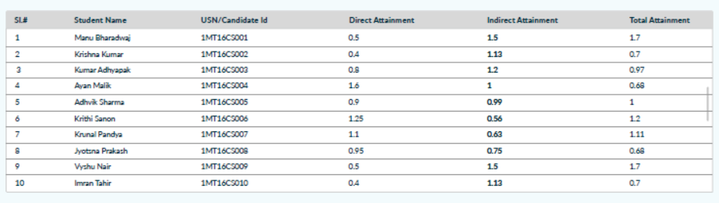

Final

